Is it Time to Update Your Surveillance System?

There Are Safety, Security, and Financial Benefits to Upgrading
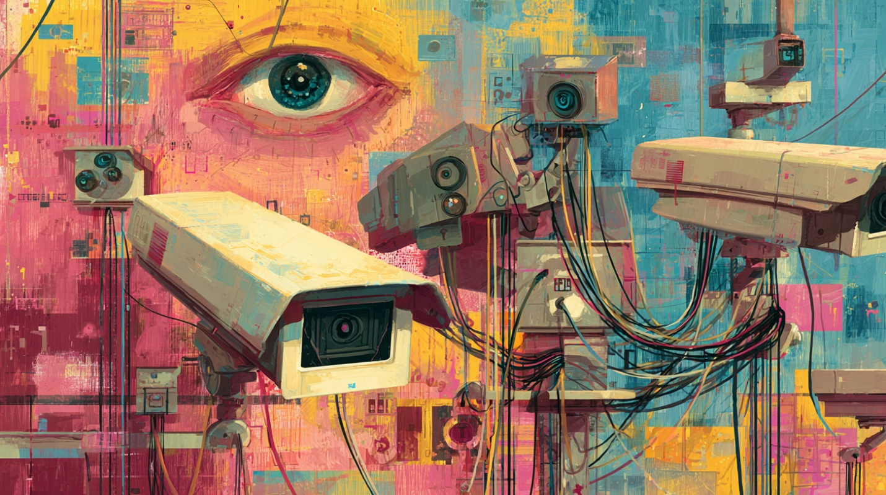

Things to consider include a higher resolution to see a person more clearly or a wider field of view. Also, better low-light performance and a wider dynamic range, so you can see things in challenging lighting conditions. Most importantly you can save security costs by using the latest AI-enhanced cameras. You save money by reducing the staffing needed to detect dangerous incidents; the intelligent cameras detect incidents and notify security as soon as they occur.

When Is It Time to Update Your Surveillance System?
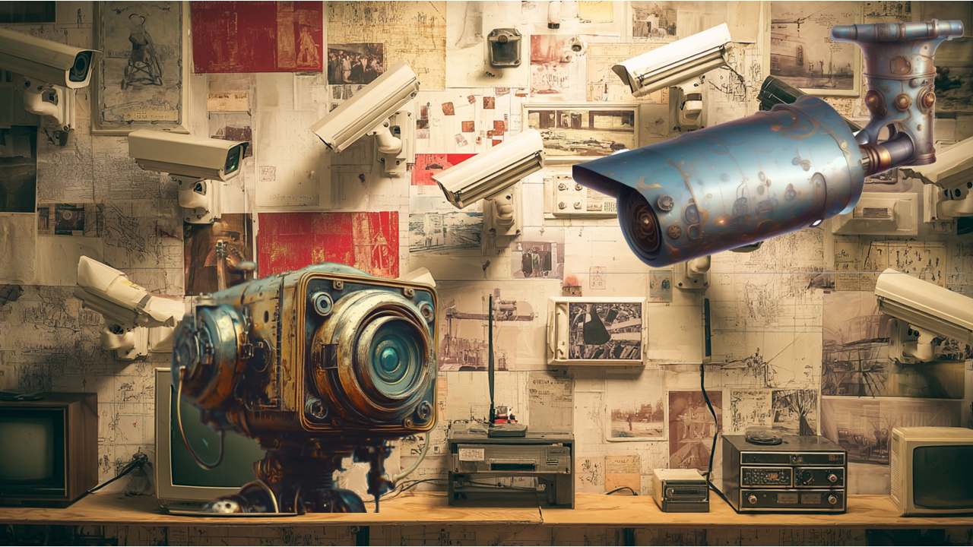
Surveillance systems play a critical role in protecting people, property, and operations. Yet many organizations continue to rely on outdated camera systems that no longer meet today’s security demands. Knowing when to upgrade can significantly improve safety while also reducing long-term costs.
If your system struggles to deliver clear images, performs poorly at night, or requires constant human monitoring, it may be time for an update.

Clearer Images with Higher Resolution
One of the most obvious signs that your surveillance system is outdated is image quality. Previous systems provided less than 2-Mpixels of resolution, and today's cameras provide over 8-Megapixels of resolution

Modern high-resolution cameras allow you to:
- Clearly identify faces, clothing, and actions
- Capture important details that older cameras miss
- Monitor wider areas with fewer cameras
Higher resolution means fewer blind spots and more usable evidence. Instead of grainy images that raise questions, you get video that provides answers.

Better Performance in Low Light and Difficult Conditions
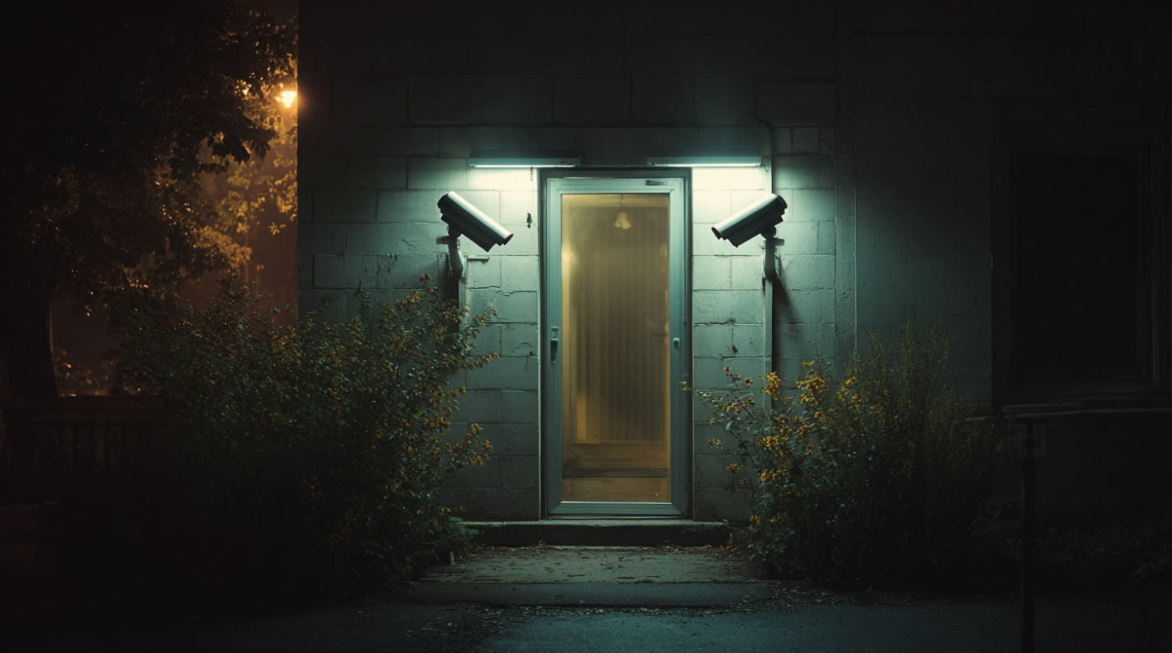
Lighting conditions are rarely ideal. Shadows, glare, bright sunlight, and nighttime environments all challenge older camera systems. While the older cameras could provide about 0.1 lux low-light performance, the latest Hanwha extraLux cameras provide low-light performance of color 0.004Lux (F0.94, 1/30sec), BW: 0.0004Lux(F0.94, 1/30sec)

Newer cameras offer:
- Superior low-light performance, allowing visibility in near-darkness
- Wide Dynamic Range (WDR) to balance bright and dark areas in the same scene
- Improved image clarity in entrances, parking areas, and mixed lighting environments
This ensures that critical details are visible when incidents are most likely to occur. For examples of high-performance IP cameras that provide excellent low-light and WDR (Wide Dynamic Range), see the Hanwha X-Series cameras.

AI-Enhanced Cameras Reduce Security Costs
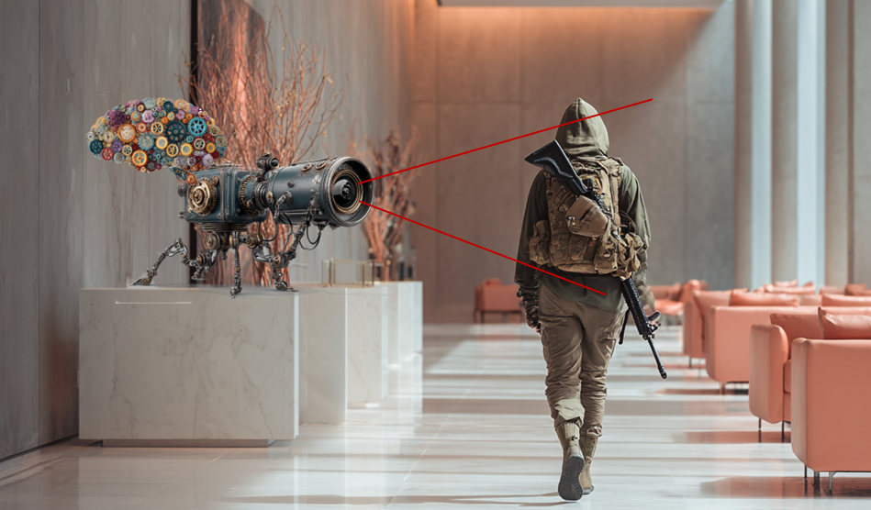
Perhaps the most important reason to upgrade is the financial impact of AI-enhanced surveillance.
Traditional systems rely heavily on people watching screens, an expensive and inefficient approach. Modern intelligent cameras change that model.

AI-enabled cameras can:
- Detect suspicious behavior, loitering, or intrusion automatically
- Identify unusual activity patterns in real time
- Detect a person carrying a gun
- Creates an alarm if someone falls
- Trigger alerts immediately when a dangerous situation occurs
This allows security staff to respond only when needed, rather than monitoring continuously. Take a look at the AI-enhanced camera systems available.

Lower Staffing Requirements, Faster Response Saves Money
By automating detection and alerting, AI-enhanced surveillance systems:
- Reduce the number of staff required to monitor cameras
- Improve response times to real incidents
- Minimize false alarms and unnecessary investigations
- Reduce loss of inventory, equipment, and facility damage
- Increase employee safety
Instead of paying people to watch video feeds, organizations can rely on technology to identify threats and notify security instantly.

When an Upgrade Makes Sense
You should strongly consider upgrading your surveillance system if:
- Video quality is too poor to identify people or incidents
- Cameras struggle in low light or high-contrast environments
- Security staff spend excessive time monitoring screens
- Incidents are discovered after the fact instead of in real time
- Operating costs continue to rise without improved results
Upgrading your surveillance system is no longer just about better cameras; it’s about better outcomes. Higher resolution and improved low-light performance provide clearer visibility. AI-enhanced analytics provides faster response and significant cost savings.
Modern surveillance systems don’t just record incidents; they help prevent them.
If your current system can’t do that, it may be time to move forward.

If you need help determining the best way to upgrade your organization’s surveillance system. Please get in touch with us at 914-944-3425, email dennis@kintronics.com, or use our contact form.

